H.T No
Regulations:
A17

Sreenidhi Institute of Science and Technology
(An Autonomous Institution)
Code No: 6B202 Date: 29-Oct-2021 (AN)

B.Tech I-Year II- Semester External Examination, Oct/Nov - 2021 (Supplementary)
ENGINEERING DRAWING – II (Common to All)

Time: 3 Hours Max.Marks:75

Note: a) No additional answer sheets will be provided.
b) All sub-parts of a question must be answered at one place only, otherwise it will not be valued.
c) Missing data can be assumed suitably.

ANSWER ANY 5 OUT OF 8 QUESTIONS. EACH QUESTION CARRIES 15 MARKS.

Bloom's Cognitive Levels of Learning (BCLL)

Remember | L1 | Apply | L3 | Evaluate | L5
Understand | L2 | Analyze | L4 | Create | L6

 |  |  | BCLL | CO(s) | Marks
1. |  | The area of a field is 50,000 sq m. The length and the breadth of the field, on the map is 10 cm and 8 cm respectively. Construct a diagonal scale which can read upto one metre. Mark the length of 235 metre on the scale. What is the R.F. of the scale? | L5 | CO1 | [15M]
2. |  | construct a vernier scale to read metres, decimetres and centimetres and long enough to measure upto 4m. The RF of the scale in 1/120. Mark on it a distance of 2.28m. | L4 | CO1 | [15M]
3. |  | A cone of base 50 mm diameter and height 65 mm rests with its base on H.P. A section plane perpendicular to V.P and inclined at 30o to H.P bisects the axis of the cone. Draw the development of the lateral surface of the truncated cone. | L4 | CO2 | [15M]
4. |  |  | L3 | CO3 | [15M]
  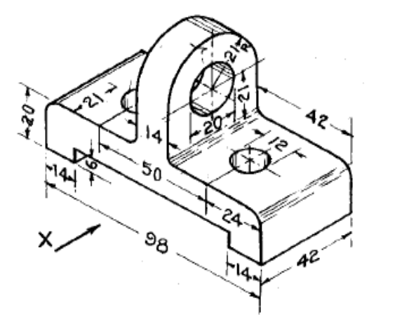
  Draw the front view , top view for the diagram shown in figure.
5. |  | For the orthographic views shown in figure, draw the isometric view  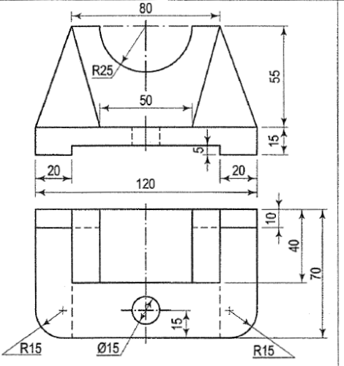 | L3 | CO4 | [15M]
6. |  | Draw the isometric view of hexagonal prism of base side 30 mm and height 60 mm when the axis is (i) horizontal (ii) vertical | L3 | CO4 | [15M]
7. |  | A rectangular pyramid, base 30 mm x 20 mrn and axis 35 mm long, is placed on the ground plane on its base, with the longer edge of the base parallel to and 30 mm behind the picture plane. The central plane is 30 mm to the left of the apex and the station point is 50 mm in front of the picture plane and 25 mm above the ground plane. Draw the perspective view of pyramid | L4 | CO5 | [15M]
8. |  | Explain about different methods of generating lines and simple solids in a computer aided drafting packages. | L2 | CO6 | [15M]

-- 00 -- 00 –

